**HW2 Team A4**

(Arthur Fu, Kevin Smutzer, Andrew Zelazny, Tyler Marsh, Neal Hamilton)

Q1. What were the time frames for each marketing campaign? How much was spent on each campaign? What was the effectiveness of previous campaigns? (40%)

|  |  |  |  |  |  |  |  |
| --- | --- | --- | --- | --- | --- | --- | --- |
| **campaigns** | **Time frames** | **Spends** | **effectiveness** | | | | |
| **Clicks** | **Cost/click** | **Sessions** | **Cost/ session** | **Bounce Rate** |
| a)whitman.syr.edu | 02/21/2011-08/27/2011 | $ 37,851.36 | 9636 | $ 3.93 | 7313 | $ 5.18 | 0.782 |
| b)MBA – Full-time | 1/17/2012-2/1/2013 | $ 76,468.56 | 8707 | $ 8.78 | 4293 | $ 17.81 | 0.8253 |
| c)MBA – iMBA | 01/31/2012-11/01/2012 | $ 128,075.98 | 18382 | $ 6.97 | 3170 | $ 40.40 | 0.895 |
| d)Delta | 10/1/2013-10/31/2014 | $ 10,000.00 | NA | NA | 30 | $ 333.34 | 0.4348 |

**a) whitman.syr.edu**

At a CPC of $3.93, the cost per lead may be expected to be fantastic considering the life time value of each student; however, with average bounce rate of 78.16%, it is clear that the landing page grossly underperformed. Better messaging or greater incentive to explore the Syracuse website may have resulted in a reduced bounce rate, increased page depth, and a higher application rate.

**b) MBA – Full-time**

At a CPC of $8.78, the cost per lead may be expected to be fantastic considering the life time value of each student; however, with average bounce rate of 83%, it is clear that the landing page is not performing. Better messaging or greater incentive to explore the Syracuse website may have resulted in a reduced bounce rate, increased page depth, and a higher application rate. Furthermore, while the goals appear to be configured correctly, not a single one was completed. This seems to indicate that neither this campaign, nor the one before it, resulted in any conversions.

**c) MBA – iMBA**

At a CPC of $6.97, it is clear that ranking for this set of keywords is more difficult than it was with the other campaigns. Additionally, with an average bounce rate of 89.5%, it is clear that the landing page is not performing. Better messaging or greater incentive to explore the Syracuse website may have resulted in a reduced bounce rate, increased page depth, and a higher application rate. Furthermore, while the goals appear to be configured correctly, not a single one was completed. This seems to indicate that neither this campaign, nor the one before it, resulted in any conversions.

**d) Delta**

It is impossible for Google Analytics to track the performance of a print advertising campaign requiring the audience to manually type a UTM code. Digging into this campaign, there were 30 sessions driven by source/medium, “delta/print.” In order to compare the effectiveness of this campaign to the other three, one may derive a cost-per-session (CPS) figure to replace CPC. In this case, CPS is $333.33 — considerably higher than any other campaign.

whitman.syr.edu

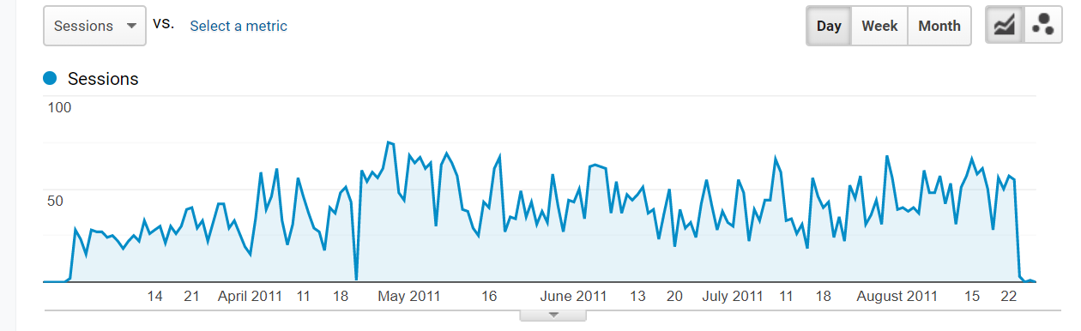

**MBA Marketing – Full-time**

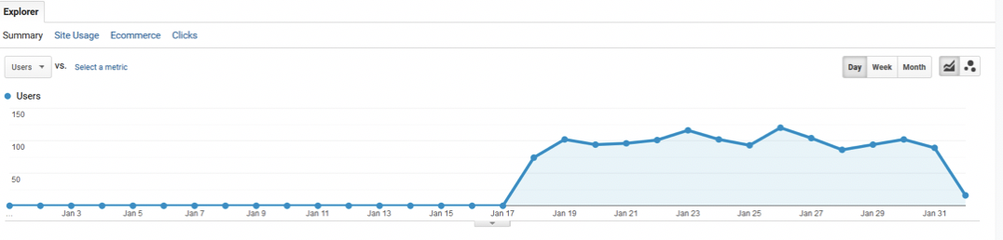

**MBA Marketing – iMBA**

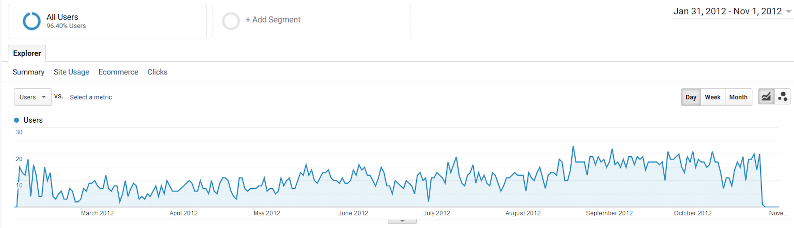

**Delta**

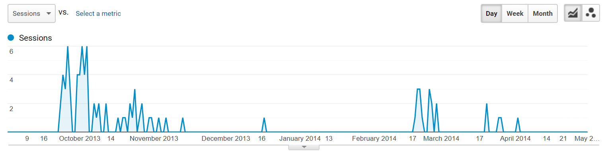

**2. Identify the key aspects of a United States campaign for next year (20%)**

* 1. **In which geographic region would you advertise? Which states? Why?**

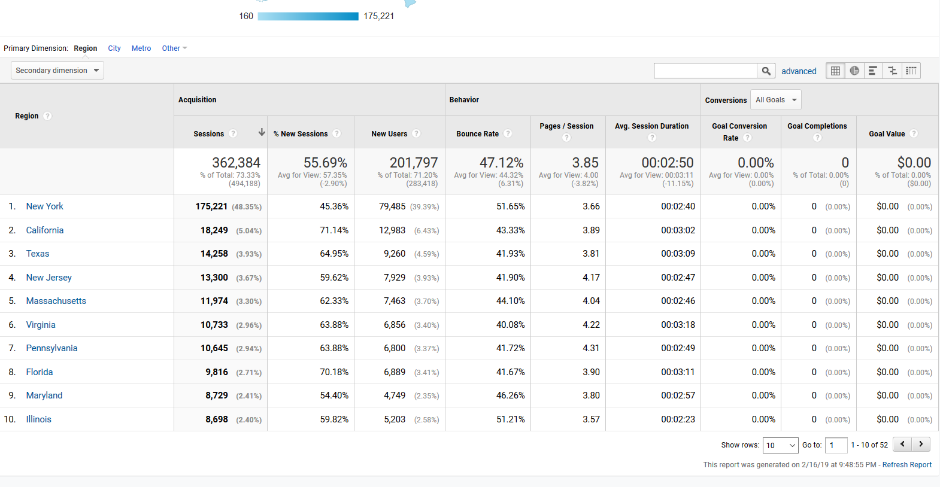

I would advertise in New York, California, and Texas. This would consist of advertising in the North East region, Southern region, and the West Coast. This culminates in the greatest number of people being targeted. Although, New York has a bounce rate of 47.12%, 47% of 175,221 is still about half 362,384 total population. Massachusetts, New Jersey, Maryland, and Connecticut, also are part of the North East region and if you add up New York to these states they account for over half the total of the sessions.

b. What key words would you use? Why?

* 1. I would use mba, +mba, and +new +york +mba, because these keywords have all seen goal conversion rates ranging from 7.33% – 17.18% from a sizeable number of sessions.

c. Which days of the week and what time of day would you advertise? Why

* 1. It depends on the region / time zone being advertised to. At a high-level, there is an exceptional amount of activity on the website on Mondays through Friday from 4pm – 10pm ET. Over the last 90 days, Wednesday has been the most trafficked with a consistent flow of between ~700 and ~1.7k users every hour from 10am ET – 9pm ET. This would indicate that Wednesday is a day when internet traffic tends to be interested in Syracuse. **Note**: These figures exclude users from Syracuse.

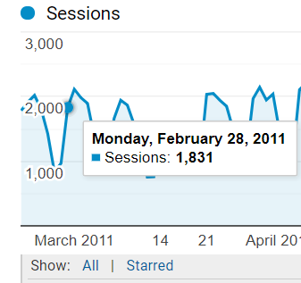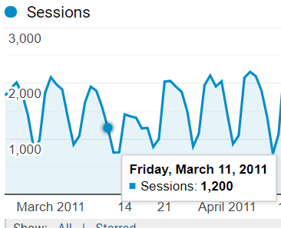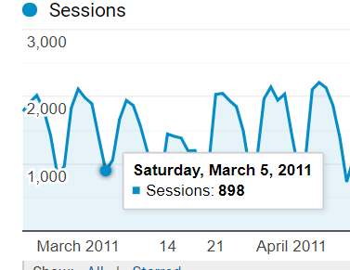

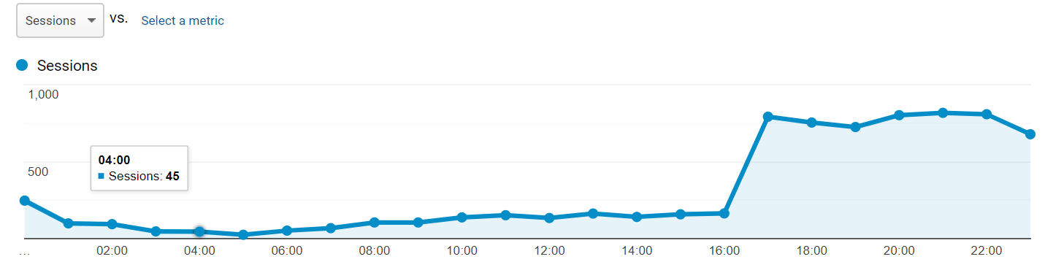3. Identify the costs for your advertising campaigns (10%)

1. **By Region**

I would spend 65% of the advertising campaigns on the Northeast region because that’s where most of the sessions come from. Then I would split the rest between recruiting the south in Texas, Georgia, and Florida and California. So, $65,000 would go to the Northeast and $17,500 to the other two regions.

1. **By Degree Program**

I would split the cost evenly throughout the programs. I think it is valuable to be able to get the Syracuse name out there for each type of program. Even though some programs may have more students, you need to think about the lifetime customer paradigm. So, a variety of majors across the different regions would be a good lifetime investment.

4. How would you measure performance of your decisions after implementation? (20%)

I would measure the performance of my decisions by sessions per $ spent and the bounce rate. I think since joining an MBA project is a huge financial and time commitment to most people we can’t measure success by measuring how big a certain class is. We just need to see how many people looked at the website and did not bounce out right away. If the website hasn’t changed then maybe, we just need more clicks for the amount of money we have invested.

I would measure the success of the campaign through the number of sessions generated, bounce rate, number of pages visited, and duration on each page. This will help to determine the effectiveness of the campaign.

In addition, I would also measure new sessions rate, which indicate the new users.

One leading indicator would be volume of goal completions. Today, Google Ads are able to optimize their messaging and targeting based on goal completions, so this will drive baseline efficiency in terms of CPC, which I will also monitor on the ad group level.

5. What other factors or considerations are important? What other data would help in developing an Internet advertising strategy, if you could collect it? (10%)

Keyword research from a tool like AHREFS would be necessary when building landing pages for these campaigns. Understanding the traffic value at the page-title level will make it easier to drive low cost traffic to high performing pages. Additionally, I would use Serpstat to find the most searched questions containing my keywords. This will inform the keywords themselves, the search ad messaging, and the titles and content of my landing pages.

I would consider how we could advertise in certain cities but not their regions. Illinois produced a large number of sessions, but the Midwest wasn’t the greatest area to advertise in. Maybe we could advertise in Chicago but nowhere else in Illinois to try to get the best cost to sessions ratio possible.

I believe it would be beneficial to capture data on career aspirations of the individuals generating the sessions through our campaign. We could gain valuable insight into what these individuals are hoping to get from their Syracuse MBA. This would allow us to better target the individuals who are the most interested in earning an MBA at Syracuse.

It would also be good to get data on GMAT scores, since we're trying to attract those students with the highest GMAT scores. Although individuals in certain regions might be creating more sessions, they may not be the individuals we are targeting. We may decide to advertise in different areas based on where the highest GMAT scores are coming from.

**Academic integrity SCREENSHOT:**

